Document BRD

This specification outlines V Mobile’s business requirements for subscriber behaviour analysis in relation to a recently launched campaign.

Business Requirements Document  
Subscriber Behaviour Analysis for Campaigns

PBT Academy  
Issue 0.001, Author Control  
July 2025

*Copyright*

*Copyright © 2019 PBT Group (SA) (Pty) Ltd.)*

*All rights reserved. Company and product names are trademarks or registered trademarks of their respective companies*

Contents

1. Project Introduction 3

1.1 Scope 3

1.2 Business Problem 3

1.2.1 Qualification Criteria 3

1.2.2 Assumptions 3

1.2.3 Business Rules 4

2. Project Solution 5

2.1 Data Analysis 5

2.1.1 Data Flow diagram 5

2.1.2 Solution Diagram 5

2.2 Data Preparation 5

2.3 Data Visualisation 6

2.3.1 Visualisation 6

2.4 Client Presentation 7

2.5 Technology 7

# Project Introduction

## Scope

The objective of this project is to build and implement a data-based reporting process for V Mobile's weekly "Free Minutes" campaign. The system will consolidate and merge subscriber information from several source systems (V Mobile, Blue Mobile, and Arrow Mobile), apply business rules to derive one distinct master record per subscriber, and generate a weekly report that measures campaign activity.

**Data Integration**

Subscriber records from V Mobile, Blue Mobile, and Arrow Mobile will be combined into one dataset. Business rules will be applied to identify a single master record per subscriber.

**Data Preparation**

Weekly Mediation system extracts of calls and SMS will be processed. Revenue, call counts, and SMS counts will be aggregated to determine campaign qualification.

**Reporting & Analytics**

A weekly report will be generated with subscriber details, revenue, and activity. A Power BI dashboard will be developed to show subscriber trends and regional insights.

**Presentation & Documentation**

The final solution will be presented to stakeholders. All scripts, processes, and outputs will be stored in a private GitHub repository.

## Business Problem

V Mobile Marketing needs to track the success of the weekly "Free Minutes" promotion but has no idea yet how many subscribers meet the qualification criteria. Marketing cannot determine the success of the campaign or make solid promotional decisions in the future without reporting properly.

### Qualification Criteria

* A subscriber qualifies if their total revenue for the week is R30 or more (from SMS or voice calls).
* Free minutes are excluded from the revenue calculations.
* A subscriber can only qualify once per week.
* For master records: priority is given to V Mobile, followed by the latest SIM activation date, and Blue Mobile over Arrow Mobile in case of ties.

### Assumptions

* All source system data is clean, complete, and accurate.
* Mediation system extracts are received weekly, covering Monday 00:00 to Sunday 23:59.
* Location names must be joined from a separate lookup table.
* Only one master record is kept per subscriber.

### Business Rules

* + - Master Record Selection:
  + If subscriber exists in V Mobile → use as master.
  + If not, select record with the most recent SIM activation date.
  + If tied, Blue Mobile takes priority over Arrow Mobile.
    - Duplicate Handling: One record per cell phone number.
    - Reporting Format: Reports must show subscriber details, revenue, SMS count, call count, and week metadata in yyyymmdd format.

# Project Solution

<<write your introduction to the solution you built>>

## Data Analysis

<<all the understanding gained during the analysis of the project>>

### Data Flow diagram

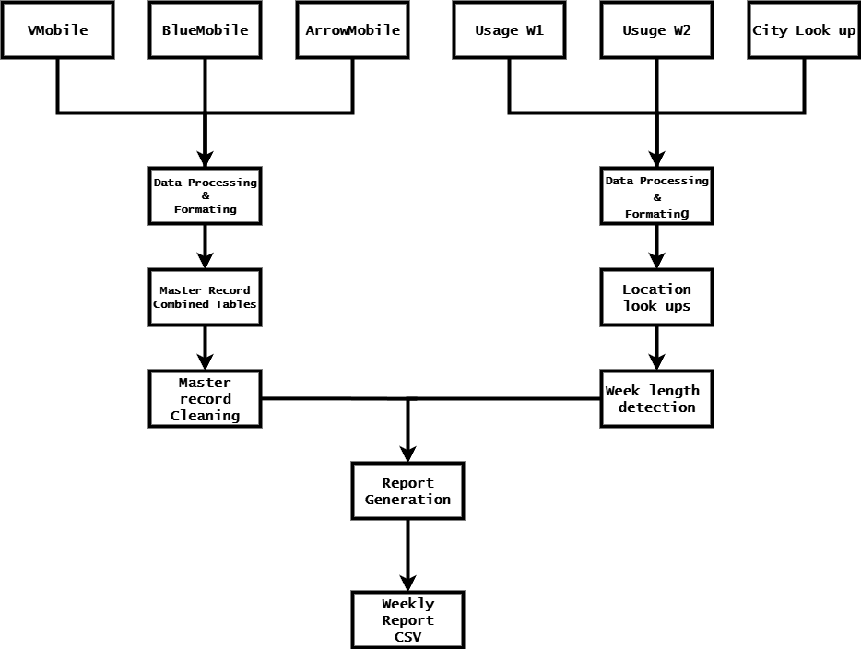

### Solution Diagram

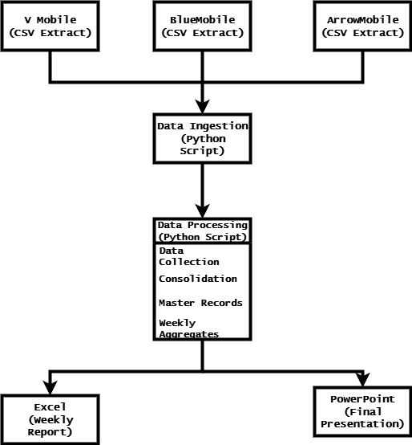

## Data Preparation

* SQL/Python scripts to combine all subscriber information from the three source systems. The following is the resulting tables:
  + **Individual tables** from the three source systems

|  |
| --- |
| VMobile_data_df = pd.read_csv('Data/VMobile_subscribers.csv', sep=';')  BlueMobile_data_df = pd.read_csv('Data/VMobile_subscribers_bluemobile.csv', sep=';')  ArrowMobile_data_df = pd.read_csv('Data/VMobile_subscribers_arrowmobile.csv', sep=';') |

* + The **combined subscriber data** **table**.
    - Combined with master record identified

|  |
| --- |
| consolidated_subscribers_df = pd.concat([consolidated_subscribers_df, other_sources_master], ignore_index=True) |

* + - The **combined subscriber data** **table**.

|  |
| --- |
| all_subscribers_df = pd.concat([vmobile_df_processed, bluemobile_df_processed, arrowmobile_df_processed],ignore_index=True) |

* + The **qualifying subscriber** **table**.

|  |
| --- |
| #Code identifing Cell Phone Numbers with more than 30 revenue in a week  high_revenue_subscribers = marketing_report_df[marketing_report_df['Total_Revenue'] > 60] # Changed to > R60 to match the requirement over R30 per week  unique_high_revenue_subscribers = high_revenue_subscribers['First_Name'].unique()  print(unique_high_revenue_subscribers) |

## Data Visualisation

The following visualisations will be created.

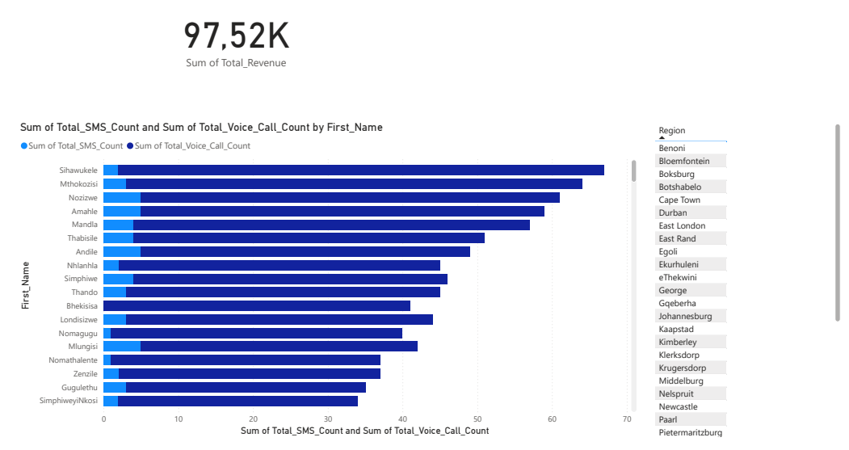

### Visualisation

The transition from raw data to an interactive dashboard was achieved through a structured process in Microsoft Excel and Power BI. The journey began with the Weekly_Marketing_Report.csv file generated by the Python script. To ensure accurate analysis, this CSV was first opened in Microsoft Excel where a critical data preparation step was performed: establishing correct data types. Each column was explicitly formatted, converting Total_Revenue to a currency field, Total_SMS_Count and Total_Voice_Call_Count to whole numbers, and confirming the date formats to prevent any processing errors during import.

This cleansed Excel file was then imported into Power BI, which preserved the defined data types and formed a stable data model. The dashboard itself was built around key interactive elements. A prominent key metric card was placed at the top of the report, instantly communicating the total value of the qualified segment by displaying the Sum of Total_Revenue (ZAR 97,520). To enable dynamic exploration, an interactive filter pane was added to the side, allowing users to slice the entire dataset by Region and First_Name. Finally, a stacked bar chart was created to visualize subscriber behaviour, comparing the volume of SMS and Voice call usage for each qualified individual, providing immediate insight into communication preferences across the customer base.

## Client Presentation

This presentation is the formal overview of the completed data solution, introducing the automated pipeline that combines subscriber data from three source systems into a single master list and produces a weekly list of customers that are eligible for the "Free Minutes" campaign. It demonstrates the interactive Power BI dashboard, through which marketing can graphically explore trends and territorial performance, and concludes with data-driven recommendations for the campaign's future direction.

## Technology

The following technology was used for each stage of the project.

|  |  |  |  |  |
| --- | --- | --- | --- | --- |
|  | **Data**  **Analysis** | **Data Preparation** | **Data Visualisation** | **Client**  **Presentation** |
| **SQL Server** |  |  |  |  |
| **Python** | x | x |  |  |
| **PowerBI** |  |  | x |  |
| **PowerQuery** |  |  |  |  |
| **Excel** |  |  |  |  |
| **PowerPoint** |  |  |  | x |
| **Canva** |  |  |  |  |